**TianEn Academy Mathematics 2024 Term 1 Final**

**Part 1: Multiple Choice (1 Mark Each)**

**Question 1:** What is the number of significant digits in the measurement 0.00470?

1. 2
2. 3
3. 4
4. 5

**Question 2:** What rule applies to zeros between two non-zero digits in significant digit counting?

1. Zeros are always significant.
2. Zeros are never significant.
3. Zeros are significant only if they are after a decimal point.
4. Zeros are significant only if they are before a decimal point.

**Question 3:** What is the upper bound for a measurement of 5.6m rounded to the nearest tenth?

1. 5.65m
2. 5.60m
3. 5.55m
4. 5.70m

**Question 4:** When calculating the upper and lower bounds of an area, you should use:

1. the exact measurements
2. the upper bound for both dimensions
3. the lower bound for one dimension and the upper for the other
4. the lower bound for both dimensions

**Question 5:** What does the slope of a distance-time graph represent?

1. Acceleration
2. Distance
3. Speed
4. Time

**Question 6:** In a velocity-time graph, the area under the curve indicates:

1. Total distance traveled
2. Average velocity
3. Instantaneous velocity
4. Acceleration

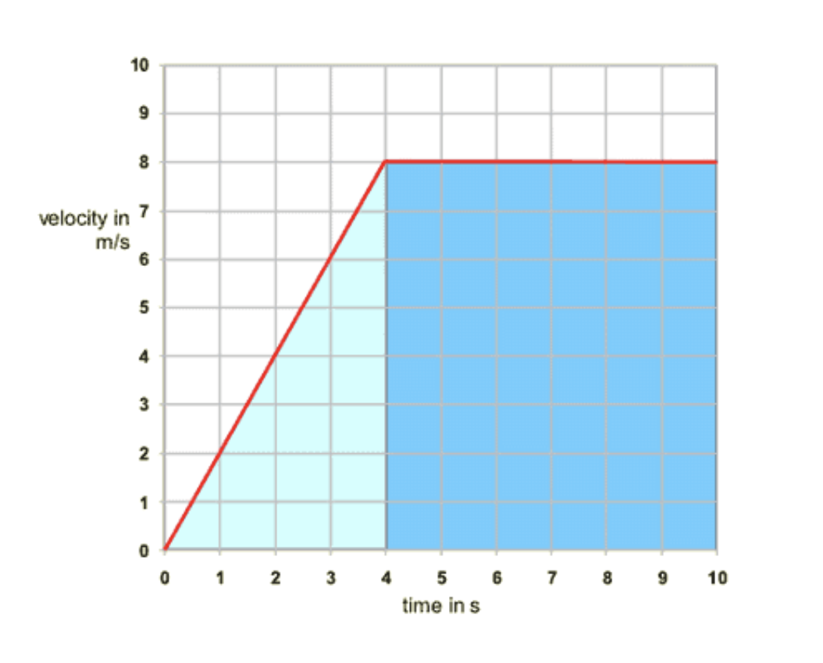

**Question 7:** Which figure shows acceleration in distance-time graph?

1. B.

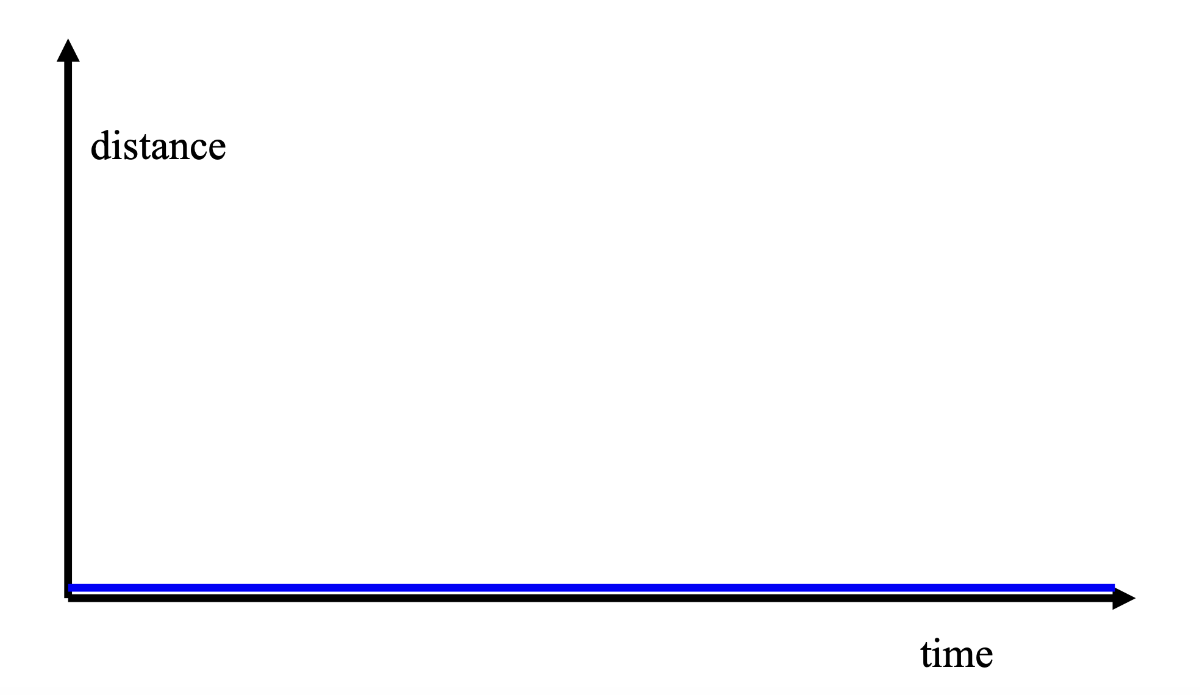 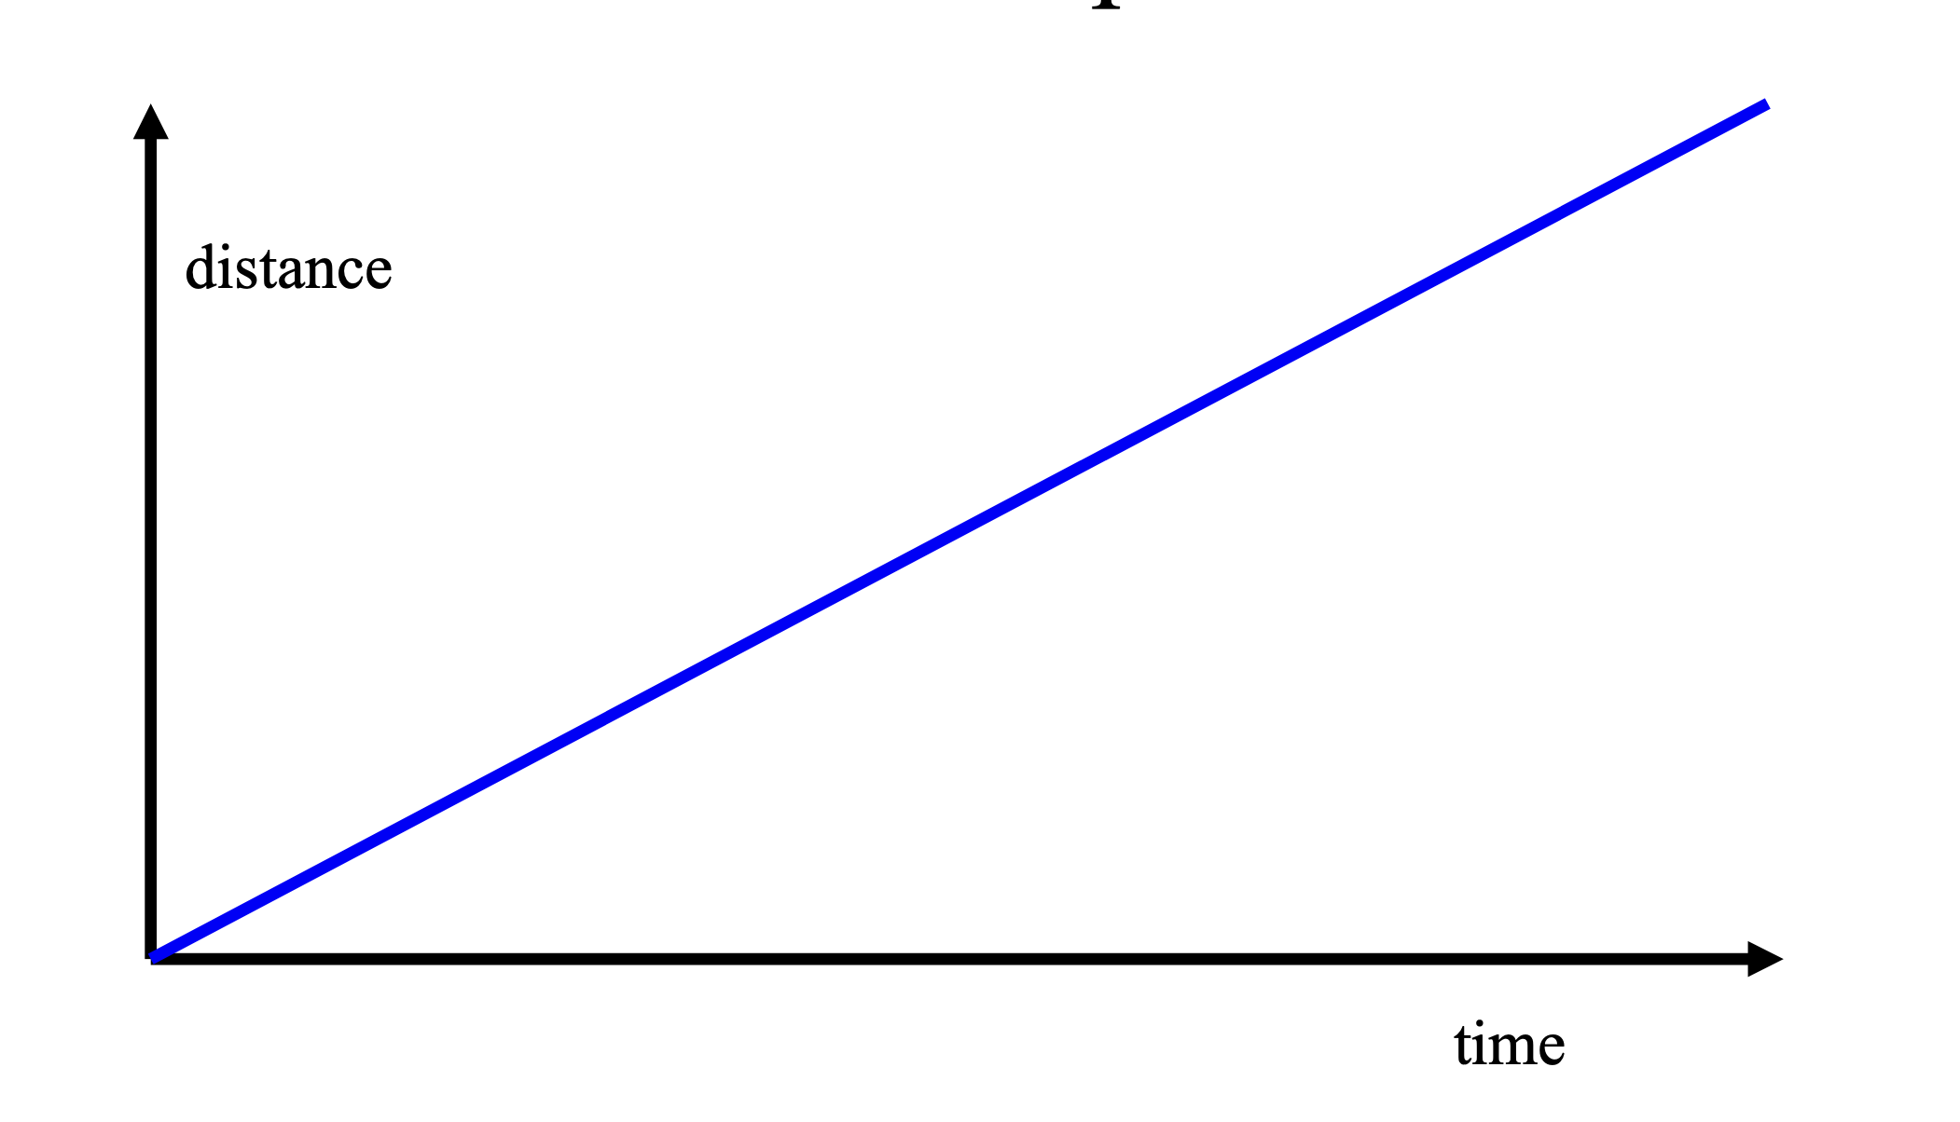

C. D.

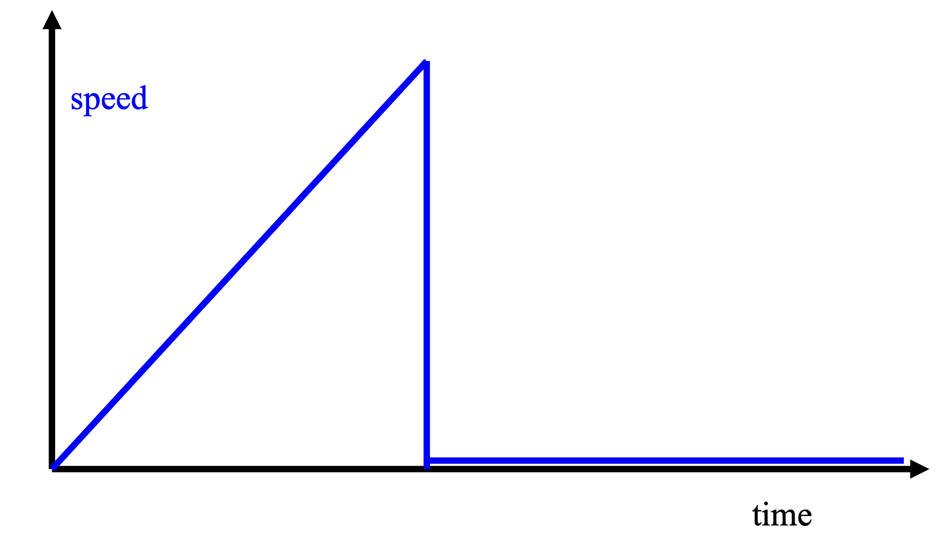

**Question 8:** Which of the following is an example of an irrational number?

1. 1/2
2. -3
3. 0

**Question 9:** Which of the following is true about rational numbers?

1. They can always be expressed as a fraction.
2. They include numbers that cannot be expressed as a fraction.
3. They are always whole numbers.
4. They cannot be negative.

**Question 10:** Rank the following types of numbers from **the smallest set** to the **largest set** as represented in the chart, and choose the correct order:

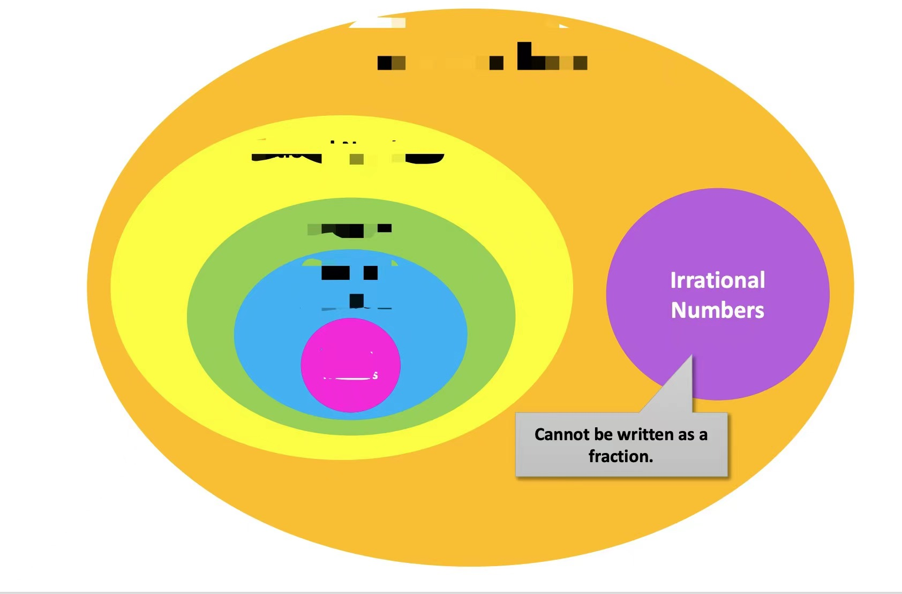

1. Natural Numbers, Integers, Rational Numbers, Irrational Numbers, Real Numbers
2. Integers, Whole Numbers, Rational Numbers, Real Numbers, Irrational Numbers
3. Rational Numbers, Irrational Numbers, Integers, Whole Numbers, Real Numbers
4. Natural Numbers, Whole Numbers, Integers, Rational Numbers, Real Numbers

**Question 11:** What is the common difference in the arithmetic sequence 2, 5, 8, 11, ...?

1. 2
2. 3
3. 4
4. 5

**Question 12:** If the recursive formula for an arithmetic sequence is and what is ?

1. 19
2. 25
3. 31
4. 37

**Question 13:** What is the simplified form of

**Question 14:** The expression is equivalent to:

1. −8
2. 16
3. −

**Question 15:** If *y* varies directly with *x* and *y* = 14 when *x* = 7, what is the constant of variation *k*?

1. 1
2. 2
3. 3
4. 4

**Question 16:** In an inverse variation, if y = and *k* = 24, what is *y* when *x* = 8?

1. 4
2. 3
3. 2
4. 1

**Question 17:** What does simple interest depend on?

1. Principal, interest rate, and time
2. Compound intervals
3. Market fluctuations
4. Account balance

**Question 18:** How is compound interest different from simple interest?

1. It is calculated only on the initial principal
2. It does not accumulate over time
3. It includes interest on the accumulated interest
4. It is only used for short-term loans

**Question 19:** Which of the following statements is true regarding the empty set?

1. It contains one element.
2. It is a subset of every set.
3. It is the set of all natural numbers.
4. It cannot be a subset of a finite set.

**Question 20:** The intersection of sets *P* and *Q* is represented by *P*∩*Q*. If *P* ={1,2,3} and *Q*={2,3,4}, what is *P*∩*Q*?

1. {1,2,3,4}
2. {1}
3. {2,3}
4. {4}

**Question 21:** What is the domain of the function defined by the set of ordered pairs {(2,−1),(3,0),(4,1),(5,2),(5,3)}?

1. {-1, 0, 1, 2}
2. {2, 3, 4, 5}
3. {2, 3, 4,5,5}
4. {0, 1, 2, 3}

**Question 22:** According to the Vertical Line Test, which of the following statements is true?

1. A curve is a function if a vertical line intersects it at exactly two points.
2. A curve is a function if a vertical line intersects it at exactly one point.
3. A curve is not a function if a vertical line intersects it at more than one point.
4. A curve is not a function if a vertical line does not intersect it.

**Question 23:** The domain of a function is the set of all possible values of x. If h(x) = , which of the following is not in the domain of h?

1. 1
2. 2
3. 3
4. 4

**Question 24:** Which of the following represents a linear function?

1. f(x) = + 2x + 1
2. f(x) = 2x + 3
3. f(x) =
4. f(x) =

**Question 25:** If a line in slope-intercept form is written as 2y+ 6*x* = 3, what is the slope of the line?

A) 2

B) 3

C) -2

D) -3

**Question 26:** If a line has a slope of 0, what kind of line is it?

A) Vertical line

B) Horizontal line

C) Diagonal line

D) Undefined

**Question 27:** Two lines are parallel if their slopes are:

A) Equal

B) Reciprocal

C) Negative reciprocals

D) Zero

**Question 28:** What is the sum of the interior angles of a pentagon?

A) 360°

B) 540°

C) 720°

D) 180°

**Question 29:** The sum of the exterior angles of any polygon is:

A) Equal to the sum of the interior angles.

B) 360°.

C) Dependent on the number of sides of the polygon.

D) Always more than 360°.

**Part 2: Fill-in-the-Blank (2 Marks Each)**

**Question 30:** In the number 2001, all digits are significant because zeros are ______ between two non-zero digits.

**Question 31:** The upper and lower bounds are used to determine the __________ range of a rounded number.

**Question 32:** In a velocity-time graph, a horizontal line above the time axis indicates a constant __________.

**Question 33:** In the arithmetic sequence with the recursive formula is , if the first term , the 5th term is _______.

**Question 34:** If the 3rd term of an arithmetic sequence is 9 and the 7th term is 21, the common difference *d* is _______.

**Question 35:** When two variables are inversely proportional, as one value increases, the other value _______.

**Question 36:** Simple interest is determined by multiplying the ________, the _________, and the ___________ between payments.

**Question 37:** When calculating compound interest, the accumulated interest from previous periods is __________ to the principal for the next period's interest calculation.

**Question 38:** If *C* is a set such that *C*={*x*∣*x* is a positive integer less than 5}, then *C* can be written as ________.

**Question 39:** The union of sets *A* and *B*, written as *A*∪*B*, includes all elements that are in *A*, *B*, or both. If *A*={1,3} and *B*={2,3}, then *A*∪*B* is ________.

**Question 40:** In a function, each input has exactly _______ output(s).

**Question 41:** If a line in slope-intercept form has an equation *y*=5*x*+2, then the line will intersect the y-axis at ______.

**Question 42:** The set of all possible inputs for a function is called the _______.

**Question 43:** If two lines are perpendicular, their slopes are _______ reciprocals of each other.

**Question 44:** In a regular octagon, the measure of each interior angle is _______ degrees.

**Part 3: Short Answer Questions**

**Question 45:**

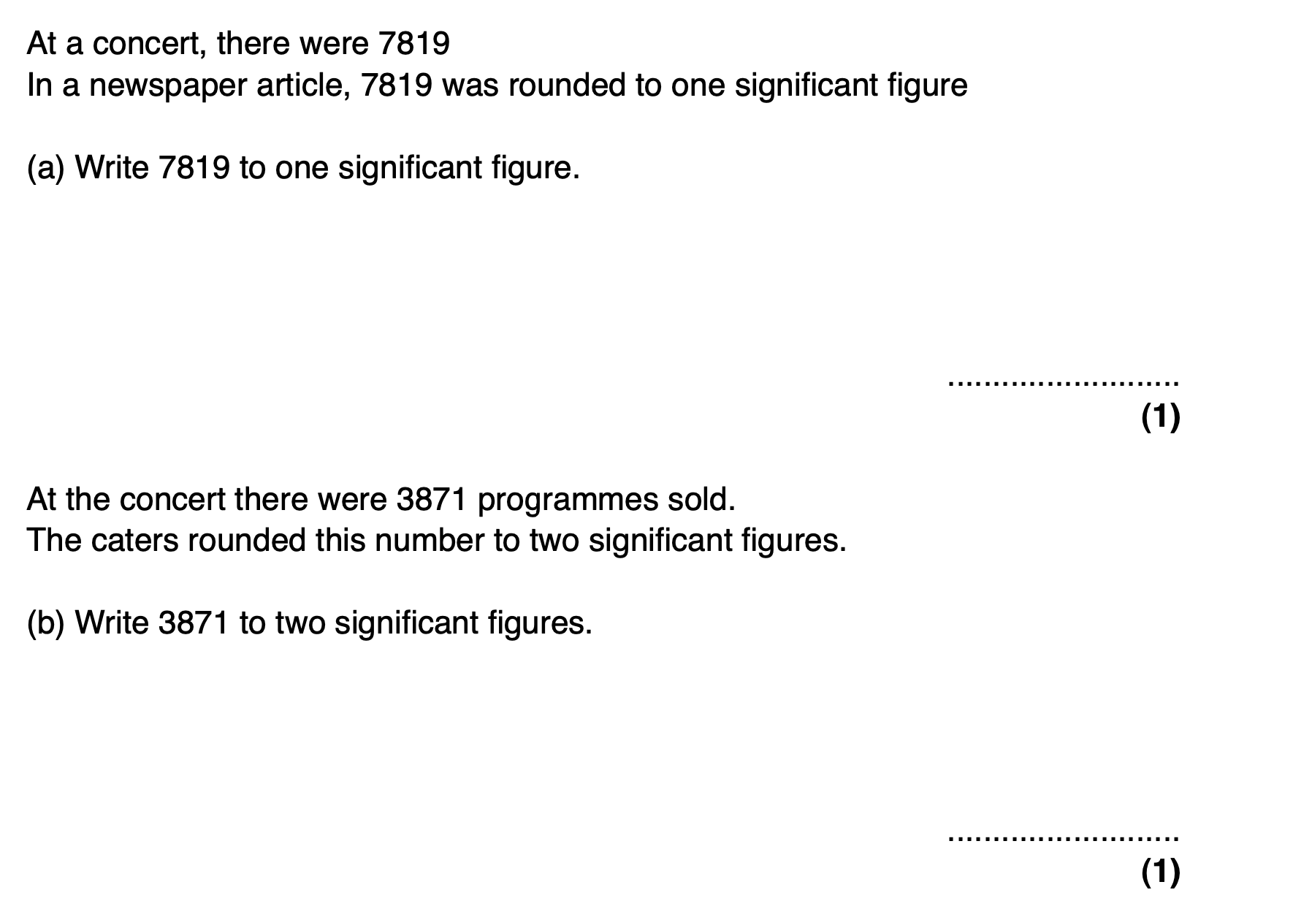

**Question 46:**

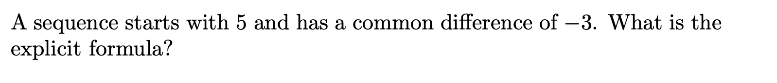

**Question 47:**



**Question 48:**

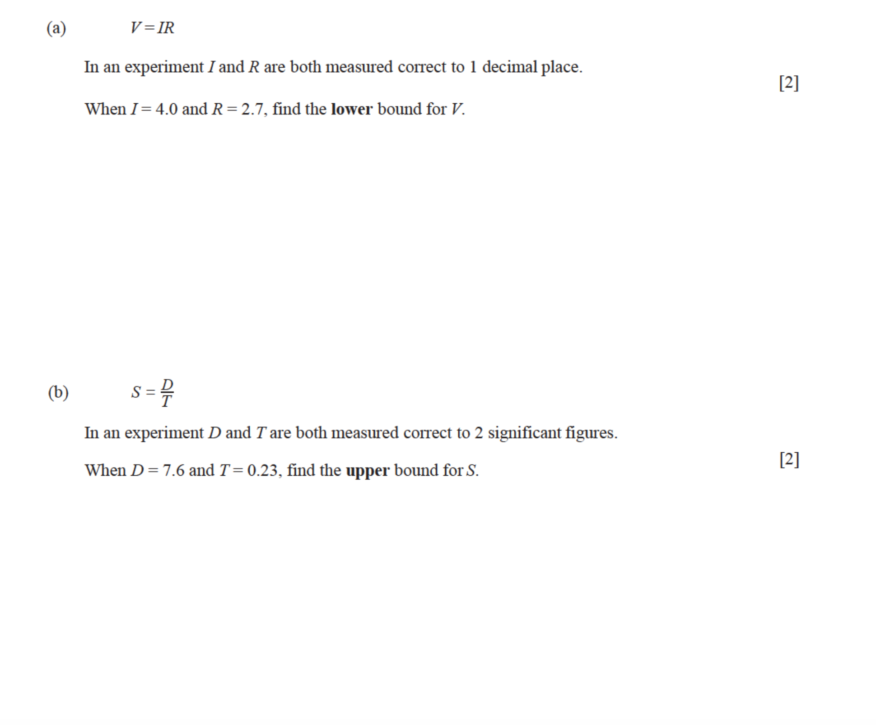

**Question 49:**

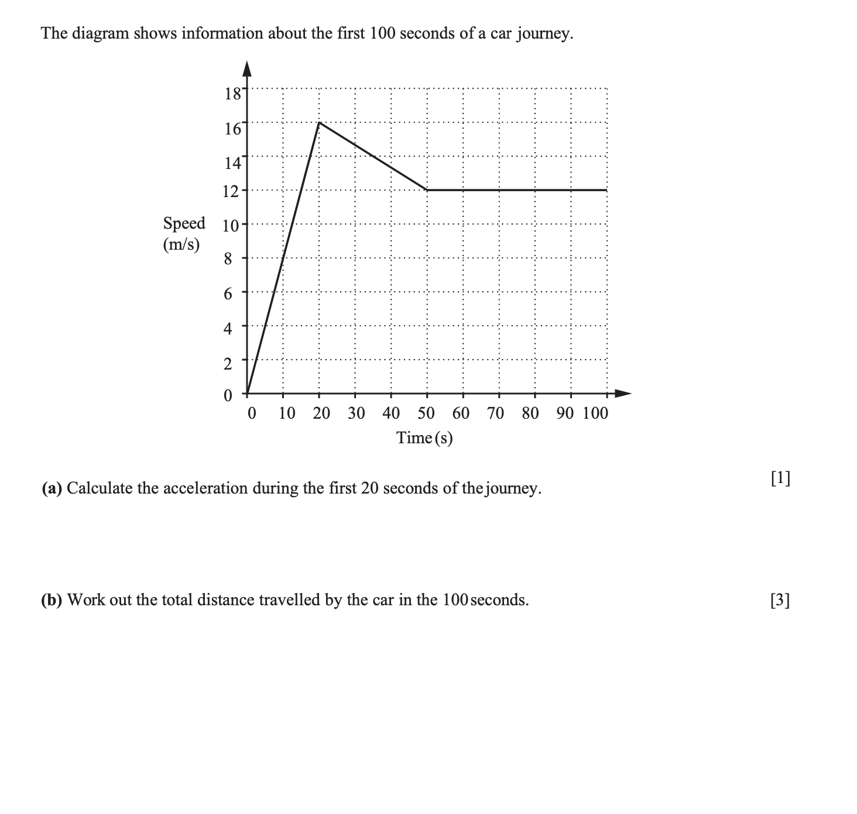

**Question 50:**

Simplify:

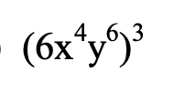

Simplify:

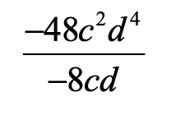

Simplify:

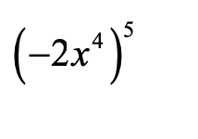

**Question 51:**

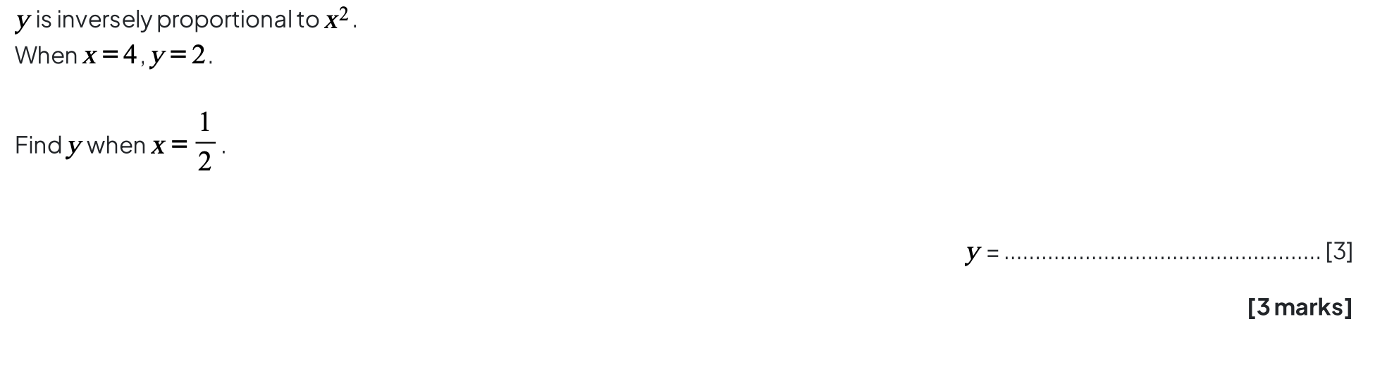

**Question 52:**

**Question 53:**

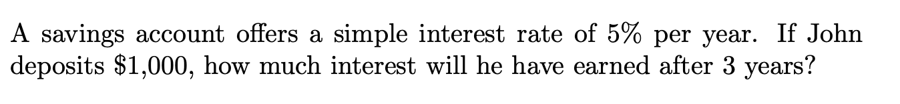

**Question 54:**

Suppose you invest $100 in a savings account that offers a compound interest of 2% compounded annually. What will be the total amount in the account at the end of 2 years?

**Question 55:**

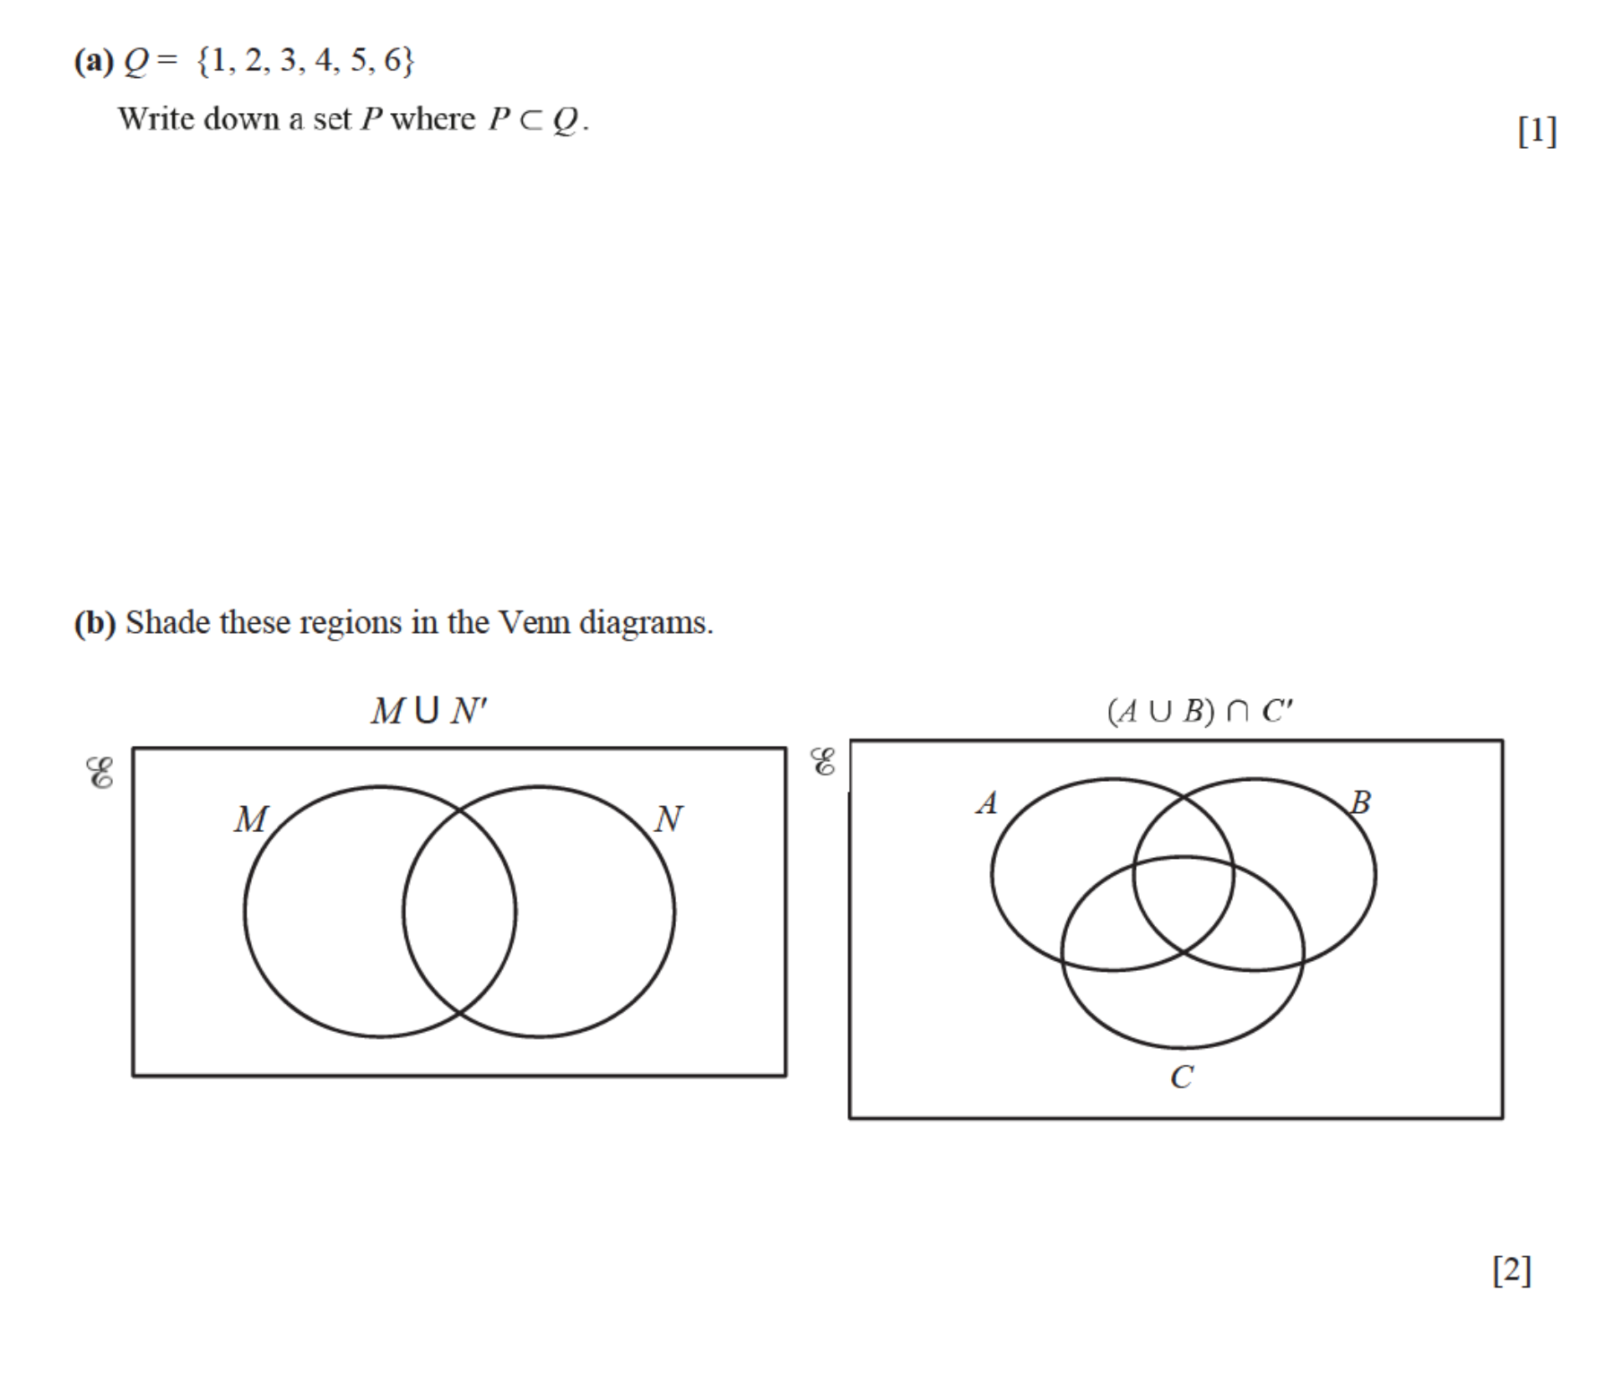

**Question 56:**

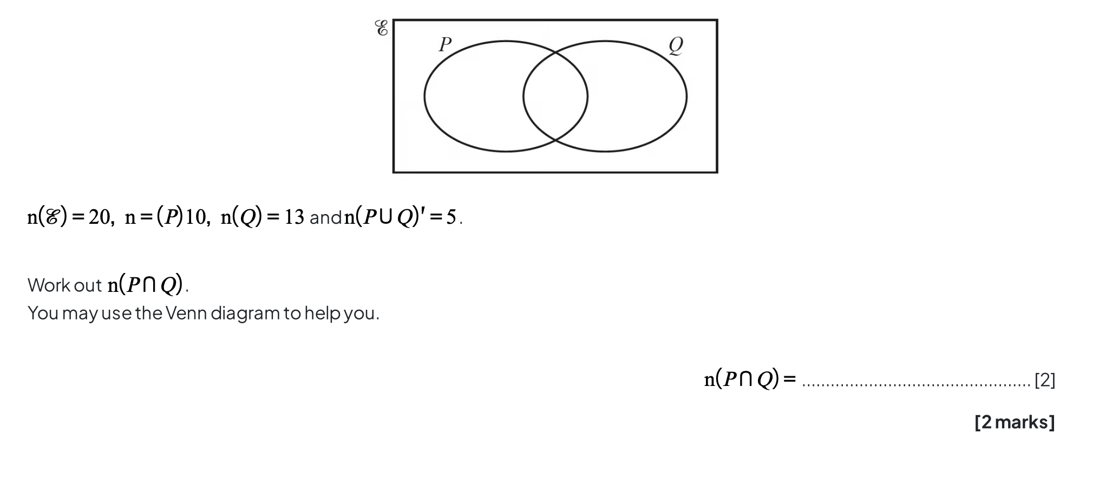

**Question 57:**

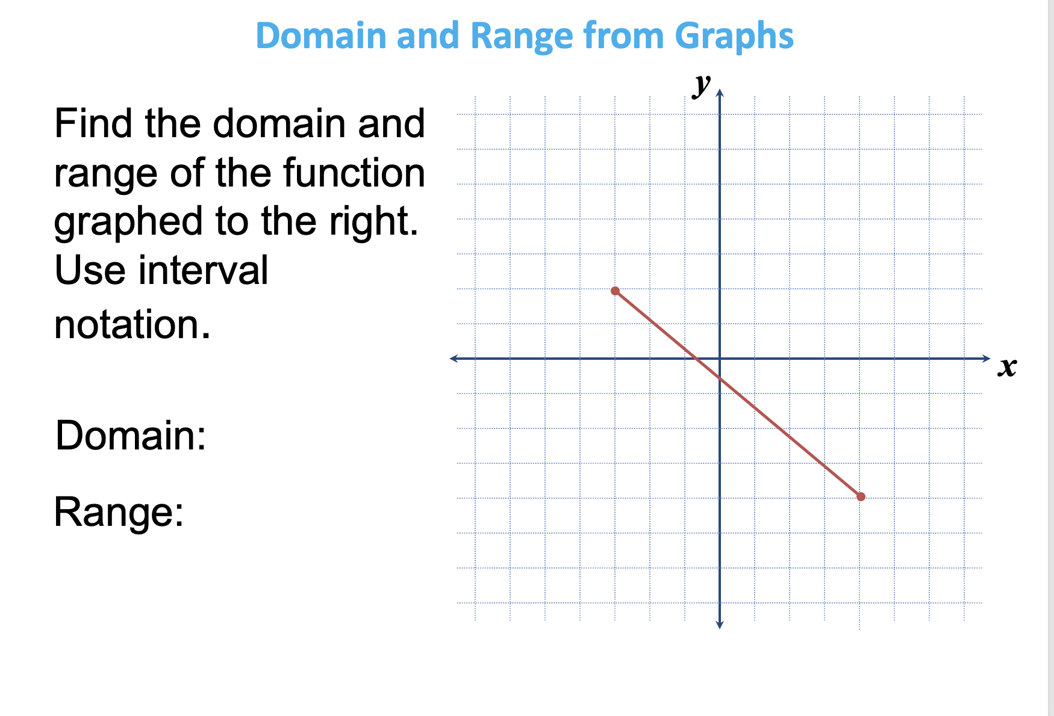

**Question 58:**

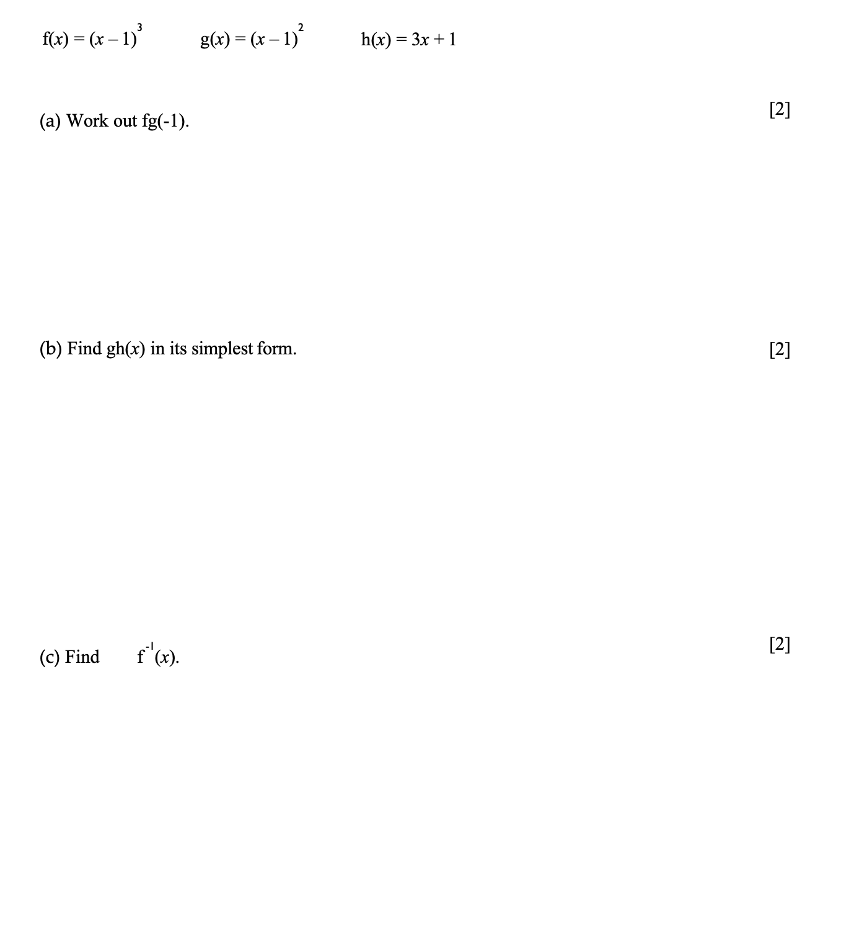

**Question 59:**

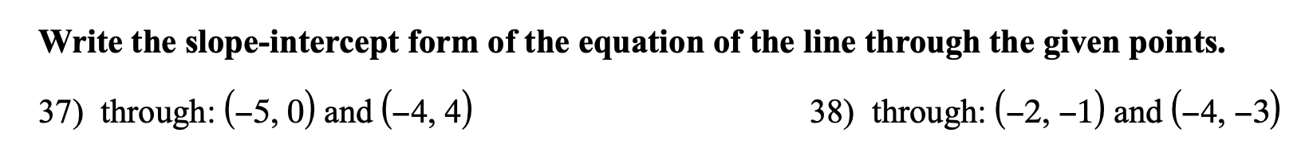

**Question 60:**

**Write the slope-intercept form of the equation of the line described.**

1. through: (4, − 3), parallel to y = − 2x
2. through:(−3,−5),perpendiculartox+2y=−4

**Question 61:**

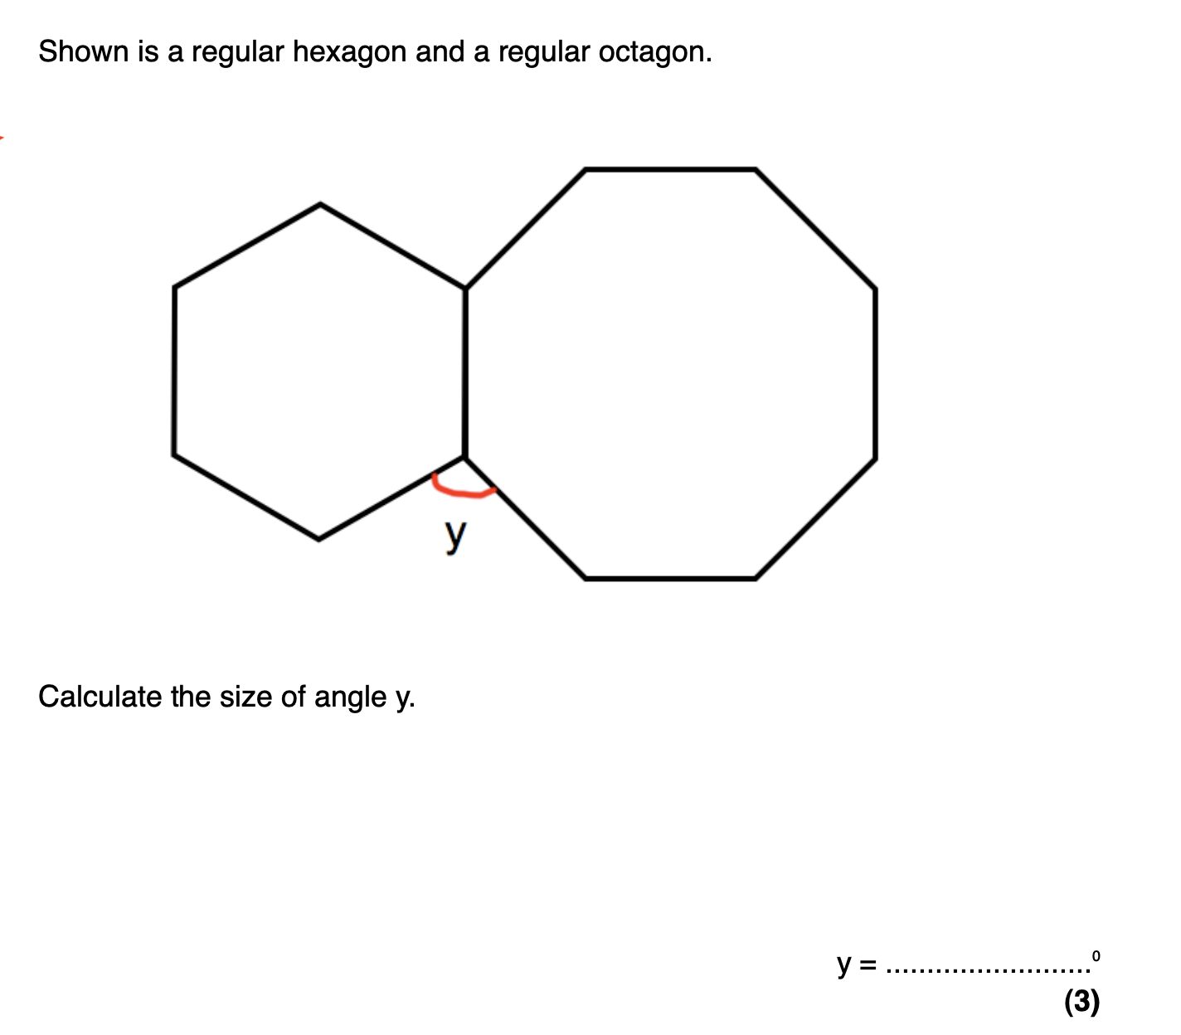

**Question 62:**

